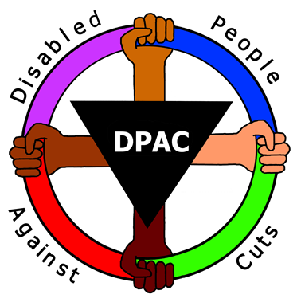
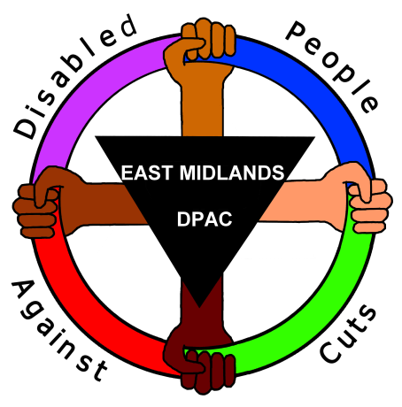
We are calling on disabled people, disabled activists, families, colleagues, friends and supporters to come together and fight back against Atos’s attacks. Atos represents as dangerous an opponent as any government, law or barrier the disability movement has faced in its long history. It’s not just welfare, but our very identity and our place within society that is under attack.
And we are asking the whole of the anti-cuts movement to join us in our opposition to the company most responsible for driving through the government’s brutal cuts agenda. Let’s make it Games over for Atos!

We’re not against the Paralympics or the people taking part in it. We’re highlighting the hypocrisy of Atos, a company that soon may be taking disability benefits from the people winning medals for Team GB.
We are calling on disabled people, disabled activists, families, colleagues, friends and supporters to come together and fight back against Atos’s attacks. Atos represents as dangerous an opponent as any government, law or barrier the disability movement has faced in its long history. It’s not just welfare, but our very identity and our place within society that is under attack.
And we are asking the whole of the anti-cuts movement to join us in our opposition to the company most responsible for driving through the government’s brutal cuts agenda. Let’s make it Games over for Atos!
We’re not against the Paralympics or the people taking part in it. We’re highlighting the hypocrisy of Atos, a company that soon may be taking disability benefits from the people winning medals for Team GB.

