Disabled People Against Cuts (DPAC)
National Conference
29th October 2011

64 people attended in person or fed their views in.

Apologies: Richard Rieser, Stephen Hodgkins, Nick Danagher, Ann Begg, Maria Miller

- Welcome and introduction to the day

Messages were read out from people who could not be with us.

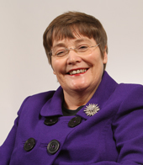
Ann Begg, Chair of the Select Committee looking into Work Capability Assessments and MP for South Aberdeen, said: “I am sorry I can’t be with you today but I have a number of events in my constituency in Aberdeen this weekend. It is important that disabled people come together to discuss and debate the issues which affect them. It is only by joining together that your voice will be heard, and people who are not disabled will hear of the attacks on your income and your ability to live a full and independent life. Good luck for a successful conference.”

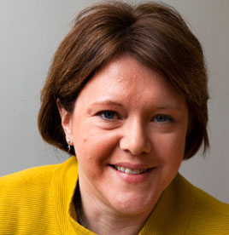
Maria Miller, Minister for Disabled People had been invited to come and speak at the conference. She gave apologies for not being able to attend but said that she was working with a number of disability organisations including Scope, Leonard Cheshire Disability, Mencap, RNIB and Mind. She also said she was working with user led organisations “like Radar.”

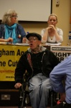
Sam Brackenbury, one of the co-founders of DPAC, sent a message to the conference to say that even though he could not be with us, we need to stay strong because we make history and because “our sunlight and spirit are NOT for sale”. He encouraged Trade Unions to remember that one out of every four people will become disabled in some way during their lifetime and stressed the importance of fighting the lie that if you are disabled and unemployed you must be a scrounging cheat.

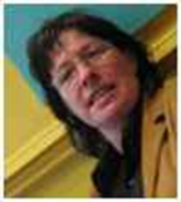
- Disabled People Against Cuts - background and achievements - Debbie Jolly
Debbie explained that DPAC started with a disabled people’s protest at the Tory party conference on 3rd October 2010. The co-ordinators of that protest went on to set up DPAC as a national campaign to fight back against the government attacks on disabled people. DPAC follows the social model of disability and is based on a rights not charity approach. Since then DPAC has worked with the Trade Unions to make sure disabled people have been included in national protests including the March for the Alternative on 26th March 2011. DPAC introduced virtual ways for disabled people to take part in protests and has a website to share information and opinions about government policy and its effect on disabled people.

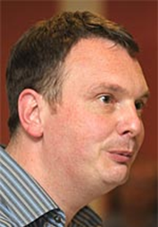
- Right to Work - Paul Brandon
Paul is the elected National Secretary of the Right to Work campaign. The campaign brings together different groups including Trade Unions and anti-cuts groups like DPAC to fight together to stand up for the rights of people who are suffering because of a financial crisis we did not create. The campaign uses direct actions, sit-ins and strikes to get its messages across. It supports all sections of people who are affected and encourages them to work together and support each other, for example student actions and disabled people’s protests against ATOS.
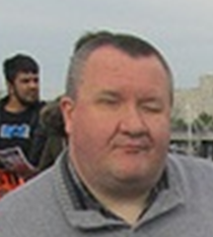
- Why We Need DPAC - Mike Higgins
DPAC member Mike Higgins spoke about why we need this campaign. He said it is not about charities keeping their funding, because disabled people have no common cause with those who beg on our behalf; it is a campaign led by and for disabled people demanding our rights to equality.
- Members’ feedback
The following point were made by members:
- We are all in it together to fight the government
- A few people had difficulty accessing the website to join as members and book to come to the conference-DPAC is working with web designer to improve access
- There is a need to set up a Liverpool DPAC
- Croydon ATOS assessment centre is not accessible to wheelchair users and people are being forced to travel for miles to get to an accessible centre
- The campaign against changes to taxi card is on-going
- We need to use real life stories to get attention to our campaign
- Employment Support Allowance is a big issue
- We need to talk about positives and what we want instead of current policy, not just focus on what we don’t want
- We need to take legal challenges
- We need to demand more funding for Disabled People’s Organisations
- Winvisible and other groups have had a letter printed in the Guardian accusing the BBC of bias against disabled people for repeatedly showing programmes about benefit fraud without any perspective on how infrequently benefit fraud actually happens

- Black Triangle - John McArdle
John founded Black Triangle, an anti-defamation campaign in defence of disabled people on June 28th 2010 in response to the suicide of friend Paul Reekie, also from Edinburgh. Black Triangle is campaigning to boycott the Paralympics in opposition to its sponsorship by ATOS. John said we need to really put a focus on putting medical professionals on the spot and campaign to scrap the idea of Personal Independence Payments. He spoke about how 15,000 had joined in a protest in Edinburgh.
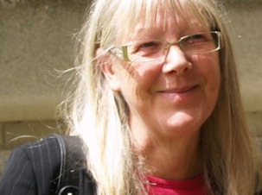
- Going forward: proposal for constituting and structuring DPAC – Linda Burnip
Linda talked about how important it is to make sure there is an on-going disabled people’s campaigning voice. For DPAC to carry on and get stronger the DPAC co-founders agreed there needed to be an elected steering group to take it forwards as well as working groups for each campaign area.
Questions and comments on the proposal:
- Steering group elections are tokenistic and create power relationships – why not just have an enlarged group of volunteers
- The social model is too theoretical and puts people off
- DPAC was set up to campaign from a basis of the social model and should continue to do so
- We should support any protest marches whoever organises them

Members voted that everyone should be on the steering group who wants to be. These are:
Andy Greene
Ellen Clifford
Linda Burnip
Patrick Lynch
Richard Rieser
Rob Murthwaite
Roger Lewis
Sarah Mingay
Stephen Hodgkins
Thomas Butler

Members also agreed there should be a wider list of people who want to be consulted and take an active part in running the campaign. In addition to the steering group members, the following people put their names down to be on this list:
- Eleanor Linsey
- Lani Parker
- Svetlana Kotovotsa
- Paul Mitler
- Richard Currie
- Jill Goble
- Phillipa Watts
- Jan Pollock
- Simone Aspis
- Stephen Aselford
- Faryal Velmi
- Sedley Bryden
- Deborah Sowerby
- Adam Lotun

- Afternoon Speakers

Including and mobilising disabled young people – Gerry Hart
This session looked at ways we can involve disabled young people in our campaigns. The point was made that informed young people make informed decisions. Ideas for how to engage young people included going to schools and to young people’s groups to let them know about DPAC, finding out and promoting the issues that young people are interested in, linking the Facebook page to other anti-cuts groups which might be visited by young people, linking our website with No One Likes a Tory.


The role of DDPO’s in the fight against the cuts – Tracey Lazard
Tracey talked about how a close, supportive relationship between campaigns and local disabled people’s organisations is critical to sustainable, effective and inclusive campaigns. She said that all the barriers that restrict disabled people from taking part in everyday life prevent disabled people from taking part in the democratic process and from campaigning. Another challenge is that there is so much to focus on at the moment that we do not know where to start. She talked about the support and resources that disabled people’s organisation can contribute to campaigns such as putting together facts and figures to support our arguments.

Taking a legal challenge in Lancashire – Melanie Close
Melanie talked about the experience of taking a legal challenge against Lancashire County Council. It was a very difficult experience and they did not win but it was the right thing to do. There was a discussion about the interpretation of the law and the judiciary’s understanding of disability equality.

Including people with learning difficulties in the fight – Andrew Lee
Andrew talked about how cuts are putting people with learning difficulties at risk. Changes in housing benefit will force people from their homes but the media is not portraying things from our point of view. With the right support people with learning difficulties can have the same chances as other people but that support needs to be funded. Cutbacks will damage the life chances of people with learning difficulties. It is important we make known the impact of cuts. Andrew encouraged members to target their MP and ask them what they have done about disability.
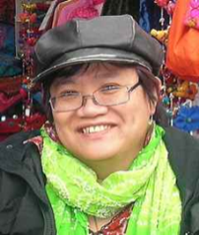
Including the BME community in the fight – Eleanor Lisney
Julia Charles sent her apologies that she was not able to attend. Eleanor led a discussion about the importance of making sure the voices of disabled people from Black and Minority Ethnic Communities are included in the fight against the cuts.

The fight for inclusive education – Simone Aspis
Simone talked about the range of threats to inclusive education being posed by this government through the standards agenda, promoting Academies, doing away with laws on the right to inclusive education, cutbacks to learning support, removing cheaper course fees and spending more money on segregated education. She encouraged everyone to lobby their MP to sign the early day motion on inclusive education.

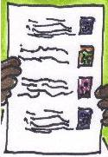
- DPAC Wish-list
Members created their wish-list of demands. The full list is at the end of these notes. Below are the demands raised by Inclusion London:
- Access to Work to extend its support to people before they get a job and to volunteer placements
- Stop Welfare reforms including:
  - the target to get 20% of people off DLA
  - Work Capability Assessment process
  - Housing Benefit changes
  - Ending the contract with ATOS
- Free personal care and re-opening the Independent Living Fund
- Ring fenced funding for Deaf and Disabled People’s Organisations in each local area including funding for independent user led advocacy and advice services for Deaf and disabled people
- Equalities Act to be strengthened by re-instating the duty to involve Deaf and disabled people, setting a requirement to have at least one equality objective on disability and strengthening the duty to carry out equality impact assessments
- Commitment to carrying out step free plans on the tube system and to keeping freedom pass and taxi card in their present forms
- Resources and training to be dedicated to tackling disability hate crime
- Right to an inclusive education
- That the Government correct outrageous levels of misinformation about disability benefit fraud in the media and produce information to promote the benefits of support such as motorbility and Access to Work
- Robin Hood tax
- Fairer distribution of income through the tax system

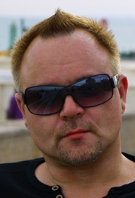
- The challenge ahead – Mik Scarlet
Mik talked about the craziness of the bank bail outs and how disabled people are having to pay for them. He talked about how the Thatcher years could, by comparison to what is happening now, be seen as a golden age for disabled people, about how disabled people are seen as over privileged and resented for benefits and support that should be our right and about his own experiences with accessible parking bays being used by non-disabled people and Blue Badges being stolen. Mik suggested we use our own stories about how the cuts are impacting on disabled people to get the media’s attention. He said this will encourage the portrayal of disabled people as tragic and in that way will have a negative impact on the way disabled people are seen but we need to do something to supersede the portrayal of disabled people as benefit scroungers which is currently how the media is showing us.
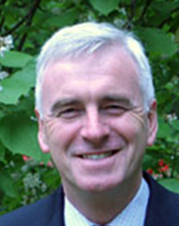
- The fight ahead – John McDonnell MP
John talked about his experiences as an MP seeing people in his constituency who have been on benefits for years now having them taken away and being left helpless. He said that New Labour laid the ground for the current government’s approach to welfare reform but cutbacks to wages and benefits was inevitably only going to lead to further recession. John encouraged us to challenge the government and resist in unity with other groups that are affected.

- Close
The co-founders were thanked for all their hard work in getting DPAC to where it is today. There is much to be done and everyone looked forward to working together to move things on.

